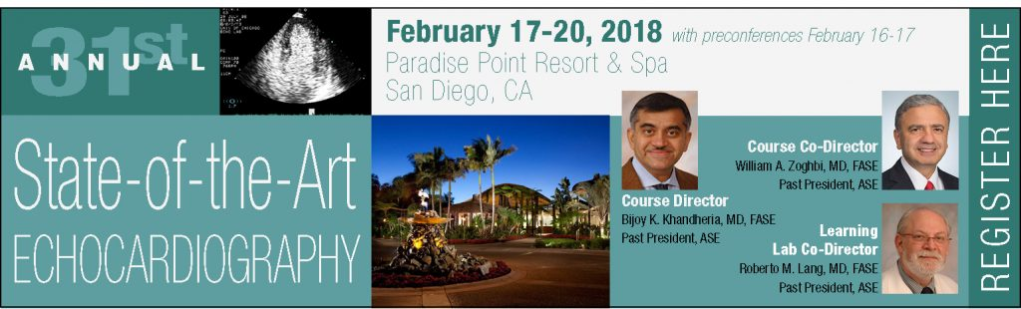

Social Media Toolkit

Dear Attendees,
Thank you for your joining us at the 31st Annual State-of-the-Art Echocardiography. State-of-the- Art Echocardiography follows the themes of structural heart disease, myocardial and pericardial disease, coronary artery disease, and interventional echocardiography. Over 100 cases will be presented by expert faculty.
We look forward to having you at State-of-the-Art Echocardiography and encourage you to use this Social Media Toolkit during the meeting as another way to engage with colleagues, and reach those who are not able to attend.
If you have any questions, please contact Arissa Cooper, ASE’s Digital Marketing Manager, at acooper@asecho.org.
Connect with ASE on the following social media channels:
- Twitter:
Account: @ASE360
Hashtag: #EchoSOTA
- Facebook: facebook.com/asecho
Hashtag: #EchoSOTA
- Instagram: instagram.com/ASE360
Hashtag: #EchoSOTA
Ways to engage on social media during State-of-the-Art Echocardiography
- Share the attached sample messages and graphics on your social media during the meeting.
- Live tweet throughout the meeting. Be sure to tag @ASE360 and use the hashtag #EchoSOTA. You can also retweet @ASE360.
- Post photos from lectures, events, and more on Facebook, Twitter, and Instagram. Don’t forget to tag @American Society of Echocardiography on Facebook, @ASE360 on Twitter, and @ASE360 on Instagram. You can also like and share ASE’s Facebook and Instagram posts with your followers.

Thank you for your participation and joining us at this year’s State-of-the-Art Echocardiography.

Sincerely,
The ASE Marketing Team

Here are a few examples of things you can post on social media.
Be creative and have fun!

For Facebook:
- I’m excited to be a part of the [tag @American Society of Echocardiography] #EchoSOTA. I’m looking most forward to attending [add presentation name] with [faculty name]
- I’m learning more about [include topics] during [add presentation name] with [faculty name] [tag @American Society of Echocardiography] #EchoSOTA

State-of-the-Art Echo Tweets
- I’m in San Diego for @ASE360 #EchoSOTA – excited for all the cases!
- Today I learned _____ in the pre-procedure #TAVR workshop #EchoSOTA
- The focus for today is structural heart disease #shd #EchoSOTA
- Learning about #3DEcho at #EchoSOTA @ASE360
- I made it to Paradise Point in San Diego for #EchoSOTA. So excited to learn from the experts in the field of #echocardiography
- Learning more about [include topics] during [add presentation name] #EchoSOTA
- Excited to learn and review while at #EchoSOTA
- Visited the exhibits at #EchoSOTA during the breaks – enjoyed talking to [exhibitor name]
- I learned so much in [add presentation name] today #EchoSOTA
- This morning I learned more about acquiring and measuring 3D/4D, Valves, and Strain in the Sonographers Workshop #EchoSOTA
- Up Next, Case Studies on #Contrast #EchoSOTA
- Next up! Case Studies: Athlete’s Heart from @robertomlang #EchoSOTA
- What was your favorite lecture from #EchoSOTA
- Enjoyed networking with colleagues and faculty tonight at the Attendee Reception #EchoSOTA
- I downloaded the ASE Courses App for #EchoSOTA. Information at my fingertips!

Graphics for Twitter, Facebook, and Instagram
Feel free to take pictures of your time with friends and colleagues around Paradise Pointe and San Diego, and use the hashtag, #EchoSOTA and tag ASE. You may also use the banner below as well. To save this graphic to your computer, right click and select “save as picture.”
