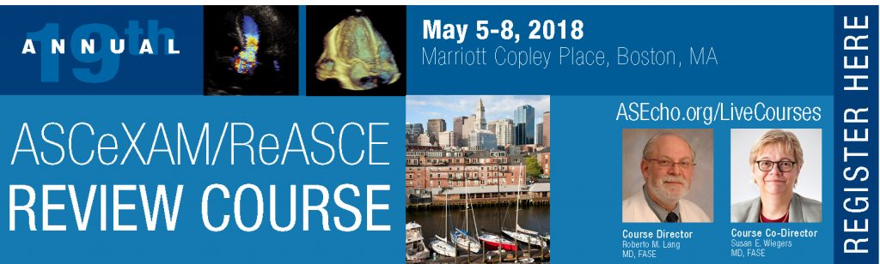
ASCeXAM/ReASCE Review Course 2018 Exhibit and Sponsorship Application
1. Exhibiting Company Information: Information should be completed exactly as you would like it to appear in onsite materials.
Company Name: Click here to enter text
Address: Click here to enter text.
City: Click here to enter text.
State/Province: Click here to enter text.
Postal Code: Click here to enter text.
Country: Click here to enter text.
Telephone: Click here to enter text.
Website: Click here to enter text.
Company Description: Click here to enter text.
2. Booth Contact Information: Only the designated contact(s) will receive exhibit communication and information.
Primary Contact Name: Click here to enter text.
Title: Click here to enter text.
Telephone: Click here to enter text.
Email Address: Click here to enter text.
Email is the primary method of communication from ASE. Pertinent exhibitor information will be emailed to the above address.

3. Attending Representative(s): Please list the names of the attending representative and their email address.
Please note: A personal email address is required if booth staff would like attend sessions and claim CME. Exhibitor staff may only attend sessions if space allows.
Name: Click here to enter text.
Email: Click here to enter text.
Name: Click here to enter text.
Email: Click here to enter text.

Name: Click here to enter text.
Email: Click here to enter text.

Name: Click here to enter text.
Email: Click here to enter text.

Name: Click here to enter text.
Email: Click here to enter text.

4. Electrical and Internet Needs:
☐Yes, I will need an electrical hook-up at my booth (additional charges may apply).
☐ No, I will NOT need an electrical hook-up at the booth.
# of plugs: Click here to enter text.
Amperage: Click here to enter text.
Voltage: Click here to enter text.
☐ YES, I will need internet access at my booth (additional charges may apply).
☐ NO, I will NOT need internet access at the booth.

5. Exhibit Type: Please indicate exhibit type below:
☐$2,500 Exhibit Space
☐$1,000 Non-Profit/Publisher Exhibit space
EXHIBIT RULES: Exhibits may include one table (Publishers are provided with two tables), a backdrop (maximum width 3 meters) and up to two echo machines. Please contact Andie Piddington (apiddington@asecho.org) if you have questions about exhibit rules.

6. Sponsorship Options: ASE offers a variety of ways to get your company name and message in front of attendees. Please select from the list below which sponsorship(s) you will be purchasing; contact Andie Piddington with any questions.
☐ Advertisements in the Final Program ($2,500): Ads are full page and will appear inside the front and back covers of the printed Final Program, which is used before, during and after the meeting, and contains information on educational programming, exhibits and special events. The Final Program will be distributed to every attendee at the Review Course.

☐ Lanyard Sponsorship ($3,500): Your corporate name and logo on lanyards given to attendees at registration will extend your visibility throughout the conference.
☐ Break Sponsorship ($1,000): Signage recognizing your sponsorship will be posted in the break area during your sponsored break.

Total Amount Due: $Click here to enter text.

7. Contract
I, the undersigned, hereby make application for exhibit space at the 2018 ASCeXAM/ReASCE Review Course. I am an authorized representative of this company with full power and authority to sign and deliver this application. Submission of this signed form is intended by you to be a binding agreement as to the terms and conditions contained herein. The company listed on this application agrees to comply with the policies, rules and regulations, and all policies, rules and regulations adopted by the ASCeXAM/ReASCE Review Course hereinafter.
Authorized Officer's Signature: _________________________________________________________
(Name typed on the line above will be the accepted electronic signature)
Title: Click here to enter text.
Date: Click here to enter a date.

8. Payment - (ASE Tax ID# 31-0899106) No company may exhibit unless full payment for booth space has been received. Full payment must be received by March 30, 2018. Company information cannot be guaranteed in the conference final program for any payments received after March 30, 2018.
☐Check payment; Check number: Click here to enter text.
☐Credit card payment: ☐Master Card ☐Visa ☐American Express
Card Number: Click here to enter text. Exp: Click here to enter text.
Name of Cardholder: Click here to enter text. Credit Card Security Code: Click here to enter text.
Please send completed forms to Andie Piddington at apiddington@asecho.org or call 919-297-7151 with any questions.
Applications may be mailed, faxed (919-882-9900) or emailed.
Andie Piddington
Corporate Relations Manager
American Society of Echocardiography
2530 Meridian Parkway, Suite 450
Durham, NC 27713
Thank you for your support!

Information for Exhibitors
PAYMENT & DEPOSIT INFORMATION
Applications for exhibit space must be received on or before March 30, 2018, to be included in printed conference materials. Applications received after this date will be acknowledged in slides shown between sessions to attendees. All exhibiting companies must submit 100% of the rental fee with the exhibit application to guarantee space. No company may exhibit unless full payment for booth space has been received.
CANCELLATION/SPACE REDUCTION
All space reductions/cancellations must be received in writing. In the event that ASE receives written notification 30 days prior to the meeting, all sums paid by the exhibitor, less a service charge of 50% of the total cost of the exhibition or sponsorship opportunity fee, will be refunded. No refunds will be given for reductions in space or cancellations received after 30 days prior to the meeting, and obligate the exhibiting company to the full payment of rental space and / or sponsorship opportunity fee.
EXHIBIT CONFIRMATION
All booth applications will receive a confirmation of receipt of the application and deposit. Booth locations will be assigned on site.
EXHIBITOR REGISTRATION PROCEDURES
ASE strongly recommends advance registration for booth staff. Only the primary contact is authorized to make changes to the complimentary badge list. ASE does not pre-mail exhibitor badges. All exhibitor personnel will be required to show photo ID and proof of affiliation with the exhibiting company (i.e., business card) to pick-up their badge on site. Only the primary booth contact will be allowed to pick-up multiple badges for distribution.
CONFERENCE MATERIAL FOR EXHIBITORS
Each exhibiting company will receive two Final Programs. These programs will be distributed to each booth during the conference.
EXHIBITOR PERSONNEL BADGES
There are two types of badges available to exhibiting companies:
Full-access Exhibitor badges: All exhibitors are entitled to five (5) complimentary full-access badges, which grant access to the Exhibit Hall as well as to educational sessions and social functions, as space allows. Full-access Exhibitor badges requested above the allotted complimentary number are $100 per person, as are replacements for lost badges. Complimentary exhibitor badges are for employees of the exhibiting company only and should not be used for other attendees. Other meeting attendees, company personnel not working the booth, employees of Exhibitor-Appointed Contractors and other third-party vendors must be registered under the appropriate professional category and may not be designated as Exhibit Staff. Exhibitor badges are non-transferrable.
Exhibit Hall Only Guest Badges: One Exhibit Hall Only Guest Badge per 10’ x 10’ exhibit space is available to each exhibiting company. If additional Exhibit Hall Only Guest badges are needed, please contact Andie Piddington (apiddington@asecho.org).

EDUCATION FOR EXHIBITORS (CONTINUING MEDICAL EDUCATION)
Exhibitors registered as full-access may earn continuing medical education (CME) credits from ASE by attending the educational sessions. All exhibitors wearing official ASE name badges will be admitted to the educational sessions as space allows. Guests of exhibiting companies and models are only allowed in the Exhibit Hall and are not permitted to attend the educational sessions.
HOUSING
Housing arrangements are the responsibility of the exhibiting company. To ensure quality accommodations, ASE has contracted a housing block for use by all ASE attendees and exhibitors. Rooms have been reserved at the hotel hosting the conference; please visit http://asecho.org/accommodationsreview/ for details. To ensure the best rate available, ASE encourages exhibitors to book rooms as soon as possible. Once the block is full, the hotel is not contractually obligated to provide rooms at the reduced rate.
PRECONFERENCE ATTENDEE MAILING LIST
An exclusive benefit only available to companies exhibiting at ASE meetings. All requests must include a copy of the mailing piece and are subject to ASE approval. The preconference mailing list will not be released to any exhibiting company until 30 days prior to the start of the conference. *Public service space exhibitors and publishers will be charged a small fee for use of the preconference mailing list.

