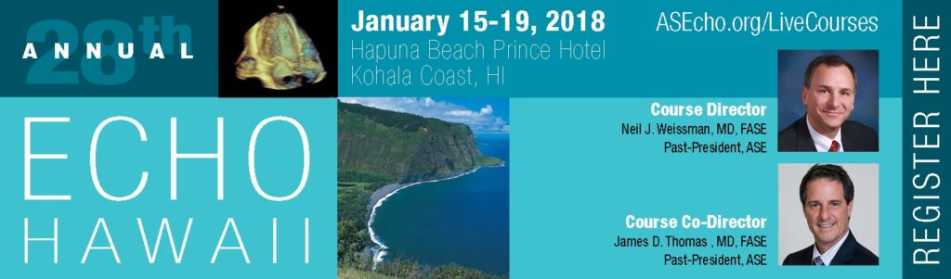

Social Media Toolkit

Dear Attendees,
Thank you for your joining us at the 28th Annual Echo Hawaii. Echo Hawaii presents the latest information on established and emerging cardiovascular ultrasound technologies.
We look forward to having you at Echo Hawaii and encourage you to use this Social Media Toolkit during the meeting as another way to engage with colleagues, and reach those who are not able to attend.
If you have any questions, please contact Arissa Cooper, ASE’s Digital Marketing Manager, at acooper@asecho.org.
Connect with ASE on the following social media channels:
- Twitter:
Account: @ASE360
Hashtag: #EchoHawaii
- Facebook: facebook.com/asecho
Hashtag: #EchoHawaii
- Instagram: instagram.com/ASE360
Hashtag: #EchoHawaii
Ways to engage on social media during Echo Hawaii
- Share the attached sample messages and graphics on your social media during the meeting.
- Live tweet throughout the meeting. Be sure to tag @ASE360 and use the hashtag #EchoHawaii. You can also retweet @ASE360.
- Post photos from lectures, events, and more on Facebook, Twitter, and Instagram. Don’t forget to tag @American Society of Echocardiography on Facebook, @ASE360 on Twitter, and @ASE360 on Instagram. You can also like and share ASE’s Facebook and Instagram posts with your followers.

Thank you for your participation and joining us at this year’s Echo Hawaii.

Sincerely,
The ASE Marketing Team

Here are a few examples of things you can post on social media.
Be creative and have fun!

For Facebook:
- I’m excited to be a part of the [tag @American Society of Echocardiography] #EchoHawaii. I’m looking most forward to attending [add presentation name] with [faculty name]
- I’m learning more about [include topics] during [add presentation name] with [faculty name] [tag @American Society of Echocardiography] #EchoHawaii

Echo Hawaii Tweets
- I’m on the Big Island for @ASE360 #EchoHawaii – excited for the Live Dissection: Aortic and Mitral Valves
- Today I learned _____ in the live dissection: normal tricuspid and pulmonary valves at #EchoHawaii
- Next up is the How to Interpret 3D Echoes #EchoHawaii
- Learning about #3DEcho at #EchoHawaii @ASE360
- I made it to the Big Island, Hawaii for #EchoHawaii. So excited to learn from the experts in the field of #echocardiography
- Learning more about [include topics] during [add presentation name] #EchoHawaii
- Excited to learn and review while at #EchoHawaii
- Visited the exhibits at #EchoHawaii during the breaks – enjoyed talking to [exhibitor name]
- I learned so much in [add presentation name] today #EchoHawaii
- Beginner’s Guide to #Strain was a great topic #EchoHawaii
- #EchoHawaii teaches how role of stress echo in valvular heart disease
- Next up! #Diastology and Advanced #Strain Workshop! #EchoHawaii
- TAVR: When Things go Wrong up next #EchoHawaii
- Interventional Echo Tips and Tricks Workshop happening now in the Hapuna Prince Ballroom #EchoHawaii
- I downloaded the ASE Courses App for #EchoHawaii. Information at my fingertips!

Graphics for Twitter, Facebook, and Instagram
Feel free to take pictures of your time with friends and colleagues around the Big Island and use the hashtag, #EchoHawaii and tag ASE. You may also use the banner below as well. To save this graphic to your computer, right click and select “save as picture.”
