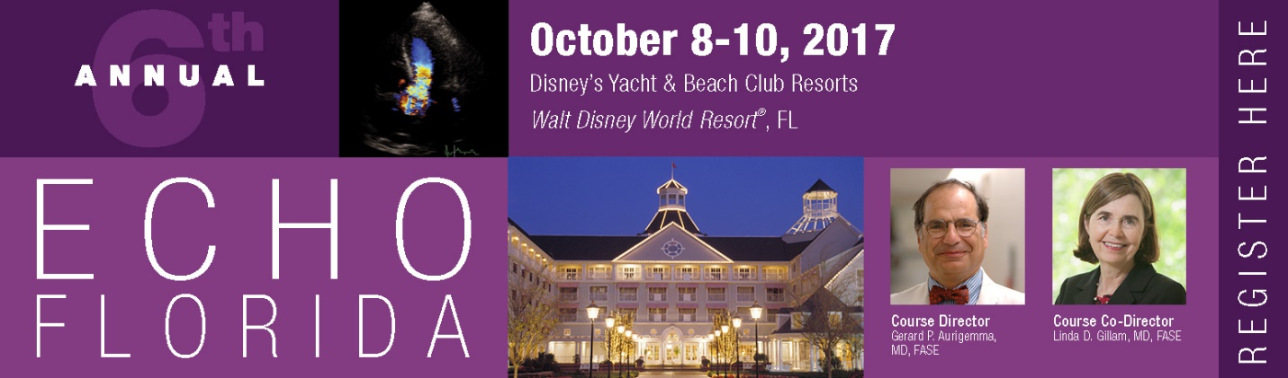

Social Media Toolkit

Dear Attendees,
Thank you for your joining us at the 6th Annual Echo Florida. The Echo Florida course has specifically been designed for those with special interest in clinical cardiology and echocardiography.
We look forward to having you at Echo Florida and encourage you to use this Social Media Toolkit during the meeting as another way to engage with colleagues, and reach those who are not able to attend.
If you have any questions, please contact Arissa Cooper, ASE’s Digital Marketing Manager, at acooper@asecho.org.
Connect with ASE on the following social media channels:
- Twitter:
Account: @ASE360
Hashtag: #EchoFlorida
- Facebook: facebook.com/asecho
Hashtag: #EchoFlorida
- Instagram: instagram.com/ASE360
Hashtag: #EchoFlorida
Ways to engage on social media during the Review Course
- Share the attached sample messages and graphics on your social media during the meeting.
- Live tweet throughout the meeting. Be sure to tag @ASE360 and use the hashtag #EchoFlorida. You can also retweet @ASE360.
- Post photos from lectures, events, and more on Facebook, Twitter, and Instagram. Don’t forget to tag @American Society of Echocardiography on Facebook, @ASE360 on Twitter, and @ASE360 on Instagram. You can also like and share ASE’s Facebook and Instagram posts with your followers.

Thank you for your participation and joining us at this year’s Echo Florida.

Sincerely,
The ASE Marketing Team

Here are a few examples of things you can post on social media.
Be creative and have fun!

For Facebook:
- I’m excited to be a part of the [tag @American Society of Echocardiography] #EchoFlorida. I’m looking most forward to attending [add presentation name] with [faculty name]
- I’m learning more about [include topics] during [add presentation name] with [faculty name] [tag @American Society of Echocardiography] #EchoFlorida

Echo Florida Tweets
- I’m at Walt Disney World for @ASE360 #EchoFlorida – excited for the #strain workshop
- Today I learned _____ in the strain workshop at #EchoFlorida
- Next up is the #3DEcho workshop #EchoFlorida
- Learning about #3DEcho at #EchoFlorida @ASE360
- I made it to Walt Disney World for #EchoFlorida. So excited to learn from the experts in the field of #echocardiography
- Learning more about [include topics] during [add presentation name] #EchoFlorida
- Excited to learn and review while at Walt Disney World #EchoFlorida
- Visited the exhibits at #EchoFlorida during the breaks – enjoyed talking to [exhibitor name]
- I learned so much in [add presentation name] today #EchoFlorida
- #EchoFlorida teaches how to recognize indications in #echo contrast agents
- #EchoFlorida teaches how to interpret #stressecho
- #EchoFlorida is helping me quantify valvular regurgitation
- Learning how to explain & abnormal findings of prostethic valve function #EchoFlorida
- I downloaded the ASE Courses App for #EchoFlorida. Information at my fingertips!

Graphics for Twitter, Facebook, and Instagram
Feel free to take pictures of your time with friends and colleagues at Walt Disney World ® and use the hashtag, #EchoFlorida and tag ASE. You may also use the banner below as well. To save this graphic to your computer, right click and select “save as picture”

