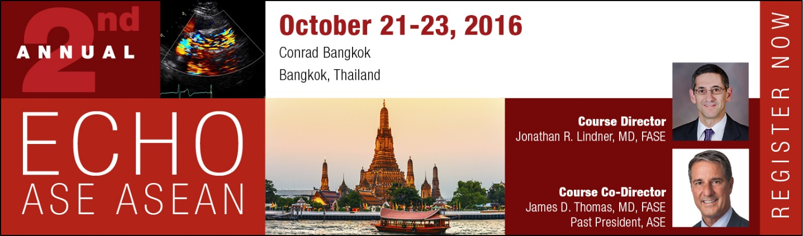

Echo ASE ASEAN Science & Technology Theater Sponsorship Agreement

Conrad Bangkok
Bangkok, Thailand
October 21-23, 2016

This agreement is entered into between the American Society of Echocardiography (“ASE”) and (“Sponsor” or “Company”), and shall be effective only when accepted and countersigned by ASE and accompanied by full payment.

In order to reserve a spot for your company to be a presenting sponsor of an industry symposium session, this signed contract and payment in full of the sponsorship fee must be received by ASE no later than September 21, 2016. The required sponsorship fee can be paid with a check (official purchase order is acceptable), credit card or wire transfer (bank fees to be incurred by the company if this option is chosen) at the time the signed contract is submitted. Your spot will not be held or guaranteed until full payment is received.
All Science and Technology Theater sessions must strictly follow all of the requirements in this agreement. If any sessions are to provide CME credit to attendees, logistics must be entirely handled by the CME provider, industry supporter and/or third party planner in full compliance with all ACCME criteria. None of these sessions will be considered an official part of Echo ASE ASEAN, as planned by the Program Committee, or in any way affiliated or endorsed by ASE.

All attendees of any Science and Technology Theater session must be registered for the Echo ASE ASEAN Conference for the day during which the session will be held (full conference registration or one-day registration may be appropriate). Five complimentary guest badges will be given for each session to be used at the company's discretion and may be used for faculty, but are good only for the date of your company’s session.

Under no circumstances may a session, staff or industry meeting, or similar event occur at the same facility during an ASE meeting without there first being a signed contract and payment in full.

The Science and Technology Theater Session will be held as follows. Theater sessions dates/times will not be considered confirmed without a signed contract and full payment. Please indicate your preferred date/time:

Friday, October 21, 2016
□ Lunch Session: 12:10pm – 1:10pm ($20,000) *** ALREADY SOLD ***

Saturday, October 22, 2016
□ Lunch Session: 11:50am – 12:50pm ($20,000)

Sunday, October 23, 2016
□ Lunch Session: 12:20pm – 1:20pm ($20,000)

The American Society of Echocardiography will provide the following for the Science & Technology Theaters:

- Tabletop Exhibit included in package (please fill out additional form for exhibit details).
- Session Room with classroom seating for 275 attendees.
- Lunch (for up to 275). Care will be taken to provide ample flow for a minimum of one full hour of programming.
- State-of-the-Art AV equipment and labor infrastructure.
- Skirted registration desk and chair.
- Provide promotional flyer to each attendee during registration
- Use of audio visual technicians (help with presentations, etc.).
- Pre-registration lists of Echo ASE ASEAN professional attendees (available in September 2016).
- Listing of session on the Echo ASE ASEAN Web site (www.asecho.org/asean).
- E-Newsletter announcement to all ASE members and ASE 2015 pre-registrants.
- Five guest badges for each industry symposium purchased.
- Access to list of Echo ASE ASEAN faculty for potential contacts for speaking roles.

Company to Provide:

- Faculty selection and invitations (faculty must either be registered for Echo ASE ASEAN as ASE faculty or company may allot one of the five complimentary badges for this purpose).
- Complete control of content.
- Complete control of lunch registration (numbers must be provided to ASE prior to the event, in alignment with banquet contractual terms, for food and beverage ordering purposes).
- Videotaping and any logistics associated with the captured symposia to allow repurposing for the Web and other venues.
- Marketing, in addition to what ASE is providing, to draw attendees.
- Company signage promoting Theater sessions (may be placed through hotel for additional promotion)
- Payment in full at the time of contract submission.
- Control of attendees (if the company would like to cap the number to allow for company personnel to attend or to discourage other competitors attending, this will be under the company’s control).
Rules Governing Distribution of Printed Materials
Company agrees to send ASE all promotional materials for review prior to printing or distribution. ASE reserves the right to modify, alter or deny any requests for material approval.

All materials associated with a Science and Technology Theater session must contain the following language “This activity is not a part of the official Echo ASE ASEAN as planned by the Program Committee, or in any way endorsed or affiliated with ASE.” This statement must be in an easily readable font on the front cover/page or mailer of all materials.

As noted in the terms above, ASE will provide on-site signage to market the location of your meeting. Any additional signs may be used at the sole approval of ASE.

ASE will not print, ship or provide any type of logistical assistance for any marketing materials not included in the list of ASE provisions of this activity (i.e. additional signs, on-site flyers, registration materials, etc.). ASE will publicize links to company-provided registration forms on the ASE Echo ASEAN Web page.

Science and Technology Theater Session Content
While sole discretion for content is given to the provider, as these sessions are for educational purposes, inducements for the reader or audience to buy or lease the sponsor’s products or services, is not advised.

Company must be solely responsible for the selection and development of content, as well as the selection and invitation of faculty. Companies may not offer honorarium or travel expenses to cover the cost of any individual who will be faculty at the official Echo ASE ASEAN.

Due to the potential for a conflict of interest, ASE leadership may not participate as faculty. ASE COI criteria prevent Executive Committee and Board of Directors members from participating in industry promotion, speakers’ bureaus and/or marketing while serving ASE in this capacity. Even though the individual may be offering a personal opinion, he/she is still perceived as speaking on behalf of ASE.
Content should be developed with careful attention to the designated time allowance. For all large Theater sessions, ASE will set the room and meal such that time is allowed for at least one hour of programming. Sessions are prohibited from interfering with the Echo ASE ASEAN educational conference and as such, may not in any circumstance go over the allotted time.
Additional Contract Terms and Disclaimer
Once a signed contract and full payment are received, no session sponsor may obtain a refund, even if the sponsor later declines to hold the session. Furthermore, the sponsorship rights in this Agreement are not transferable to any other party without the prior written consent of ASE, which consent may be withheld in its sole discretion.

Company agrees to protect, indemnify and hold ASE harmless from any and all claims, liability, damages or damage to property incurred as a result of the Science and Technology Theater sessions or connected to wrongful acts of the company, contractors or its agents.
The company listed on this application, by signing this form, agrees to comply with the policies, rules and regulations contained in this document and all policies, rules and regulations related to the session/company adopted after the distribution of this contract.
The association will only agree to provide the services listed within this contract; any other verbal discussions or representations by ASE staff, leadership or volunteers are not guaranteed.

In the event that the Echo ASE ASEAN meeting is canceled in its entirety for any reason, ASE shall return to Sponsor its sponsorship fees, but shall have no other liability or obligation. In the event that the Echo ASE ASEAN meeting is held, but sponsor’s session is interrupted in whole or in part by circumstances beyond the control of ASE, including, but not limited to, power or equipment failure, acts of God, civil disorder, labor unrest, or other emergency, Sponsor understands and agrees that it is not entitled to a refund of its sponsorship fee, but that ASE may in its sole discretion offer future concessions or opportunities.

Any questions concerning the Echo ASE ASEAN Science and Technology Theater opportunity, as well as completed forms should be sent to Andie Piddington at apiddington@asecho.org or 919-297-7151.

In witness whereof, the Sponsor, by its authorized representative, agrees to the foregoing terms and conditions of the Agreement and its exhibits. (Please note that electronic and facsimile signatures are acceptable and binding)

COMPANY NAME: _______________________________________

Authorized Signature:
Printed Name:
Title:
Date:
Attachment: Exhibit A

Payment in full is acknowledged and this Agreement is accepted by ASE as of the date indicated below:

AMERICAN SOCIETY OF ECHOCARDIOGRAPHY

Authorized Signature:
Printed Name:
Title:
Date:

Exhibit A: Company Contact Information

Company Name

Primary Symposium Contact
Name:
Email:

Address:
 | Street Address
 | City | State | ZIP Code

Phone: |  | Fax:

Secondary Symposium Contact
Name:
Email:

Address:
 | Street Address
 | City | State | ZIP Code

Phone: |  | Fax:

CME Provider and Contact Information (if applicable)

Third-Party Organizer and Contact Information (if applicable)

Exhibit B: Wiring Instructions

ACH Instructions
Routing #: 053101121
Account #: 5202927868
Account Name: American Society of Echocardiography

International Wire
BB&T
434 Fayetteville Street
Raleigh, NC 27601

Swift Code:- BRBTUS33

American Society of Echocardiography

Account:- 5202927868

All Bank Fees must be paid by initiator. Please send Wire Confirmation and Remittance Information to accounting@asecho.org.

