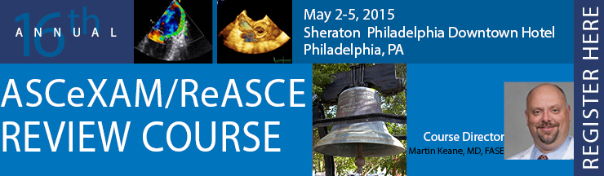
ASCeXAM/ReASCE Review Course 2015 Exhibit and Sponsorship Application
1. Exhibiting Company Information: Information should be completed exactly as you would like it to appear in onsite materials.
Company Name: Click here to enter text
Address: Click here to enter text.
City: Click here to enter text.
State/Province: Click here to enter text.
Postal Code: Click here to enter text.
Country: Click here to enter text.
Telephone: Click here to enter text.
Fax: Click here to enter text.
Email address: Click here to enter text.
Website: Click here to enter text.
2. Booth Contact Information: Only the designated contact(s) will receive exhibit communication and information.
Primary Contact Name:
Title: Click here to enter text.
Telephone: Click here to enter text.
Fax: Click here to enter text.
Email Address: Click here to enter text.
Email is the primary method of communication from ASE. Pertinent exhibitor information will be emailed to the above address.

3. Attending Representative(s): Please list the names of the attending representative and their email address.
Please note: A personal email address is required if booth staff would like attend sessions and claim CME. Exhibitor staff may only attend sessions if space allows.
Name: Click here to enter text.
Email: Click here to enter text.
Name: Click here to enter text.
Email: Click here to enter text.
Name: Click here to enter text.
Email: Click here to enter text.
☐Yes, I will need an electrical hook-up at my booth.
☐ No, I will NOT need an electrical hook-up at the booth.
# of plugs: Click here to enter text.
Amperage: Click here to enter text.
Voltage: Click here to enter text.

5. Please indicate exhibit type below:
☐$2,500 Exhibit Space
☐$1,000 Non-Profit/Publisher Exhibit space

6. Please select from the list below which sponsorship you will be purchasing. Your sponsorship allows ASE to continue to provide quality cardiovascular ultrasound education.
☐Advertisements in the Final Program ($4,500)
☐Lanyard Sponsorship ($3,500)
☐Welcome Reception Sponsorship ($2,500)
Amount Due: $Click here to enter text.
7. Contract
I, the undersigned, hereby make application for exhibit space at the 2015 ASCeXAM/ReASCE Review Course. I am an authorized representative of this company with full power and authority to sign and deliver this application. Submission of this signed form is intended by you to be a binding agreement as to the terms and conditions contained herein. The company listed on this application agrees to comply with the policies, rules and regulations, and all policies, rules and regulations adopted by the ASCeXAM/ReASCE Review Course hereinafter.
Authorized Officer's Signature: _________________________________________________________
(Name typed on the line above will be the accepted electronic signature)
Title: Click here to enter text.
Date: Click here to enter a date.

8. Payment - (ASE Tax ID# 31-0899106) No company may exhibit unless full payment for booth space has been received. Full payment must be received by April 14, 2015. Company information cannot be guaranteed in the conference final program for any payments received after April 14, 2015.
☐Check payment; Check number: Click here to enter text.
☐Credit card payment: ☐Master Card ☐Visa ☐American Express
Card Number: Click here to enter text. Exp: Click here to enter text.
Name of Cardholder: Click here to enter text. Credit Card Security Code: Click here to enter text.
Please contact Brandi Delany at bdelany@asecho.org or 919-297-7171 with any questions.
Applications may be mailed, faxed or emailed.
Brandi Delany
Meeting Planner
American Society of Echocardiography
2100 Gateway Centre Blvd. Suite 310
Morrisville, NC 27560
Thank you for your support!

