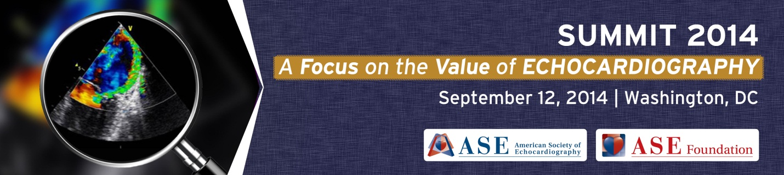

SUMMIT 2014 Sponsorship Agreement
JW Marriott Hotel
Washington, DC
September 12, 2014

This agreement is entered into between the American Society of Echocardiography Foundation (“ASEF”) and (“Sponsor” or “Company”), and shall be effective only when accepted and countersigned by ASEF and accompanied by a $2500 (50%) payment.
Sponsorship Package: $5,000
Sponsor name and logo will appear:
- Throughout the Summit website
- In e-blasts promoting the Summit to all ASE members and potential guests
- In press releases promoting the Summit
- On display boards and screens throughout the event
- In the formal conference summary report issued after the event (to be published in the Journal of the American Society of Echocardiography- JASE)
Also includes:
- Five (5) complimentary organization employee registrations
- Access to the final list of participants

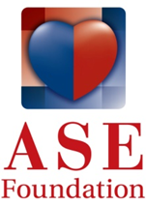
Sponsoring Company Information: Information should be completed exactly as you would like it to appear in all promotional materials.
Company Name: ______________________________________________________________
Brief Description of Company: ___________________________________________________
_____________________________________________________________________________
Address: _____________________________________________________________________
City: ____________________________________ State: ________________ Zip: ___________
Phone: ___________________________________ Fax: _______________________________
Contact Name: ________________________________________________________________
Email: _______________________________________________________________________
This document may be copied and emailed to Andie Piddington (apiddington@asecho.org).
ASE Office Use
____________________
DATE:
____________________
AUDITOR:
____________________
Company Name __________________________________
Authorized Signer* (print) __________________________________
Signature __________________________________
Date __________________________________

*The person signing this form represents that they are an authorized signer on behalf of the organization
Special Note: Sponsorships are not confirmed until deposit payment is received. Full payment must be made prior to August 12, 2014. The required sponsorship fee can be paid with a check (official purchase order is acceptable), credit card or wire transfer (bank fees to be incurred by the company if this option is chosen) at the time the signed contract is submitted.
In the event that the 2014 Summit is canceled in its entirety for any reason, ASEF shall return to Sponsor its sponsorship fees, but shall have no other liability or obligation to the company.
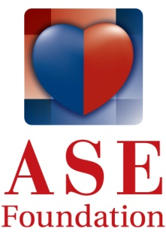
Checks should be made payable to ASE Foundation and sent to 2100 Gateway Ctr. Blvd, Ste. 310, Morrisville, NC 27560.

